1. Install Virtualbox
2. Install Centos 7
3. Create user as your first letter in the first name and last name
4. Go to your home directory
5. Create subdirectories in your home directory with your username + 1 & 2
6. Create a file with your username
7. Change the permissions for the file to read and write but not execute
8. Change the permissions for the file to read and execute but not write
9. Write two lines in a file and display it to the screen
10. Install Virtualbox
11. Install Centos 7

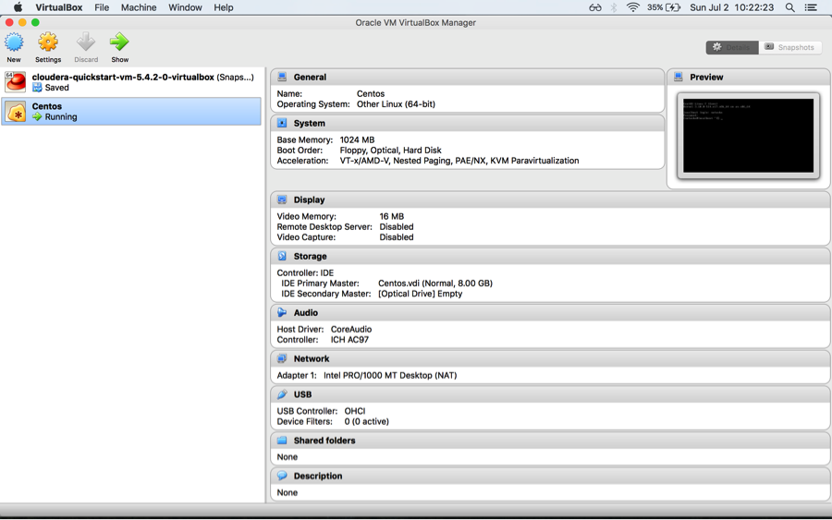

Created user as username=Natasha (first name)

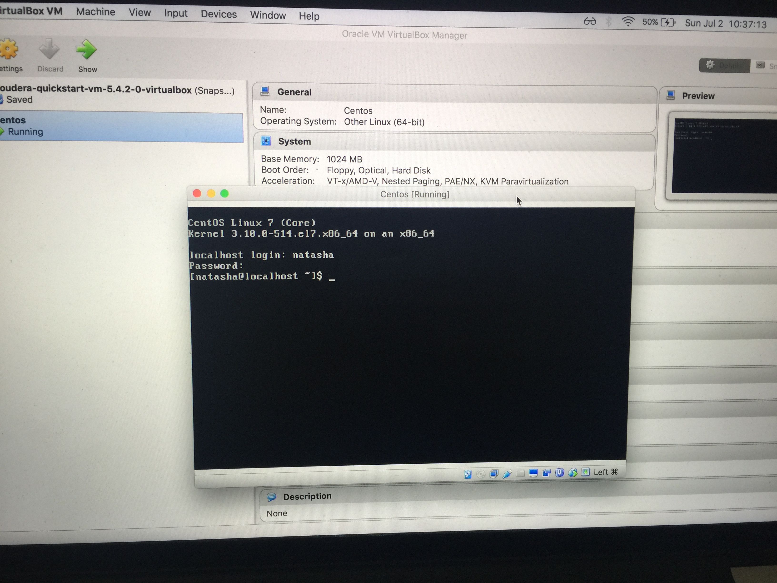

Go to home directory and create subdirectories in your home directory with your username + 1 & 2

Change the permissions for the file to read and write but not execute

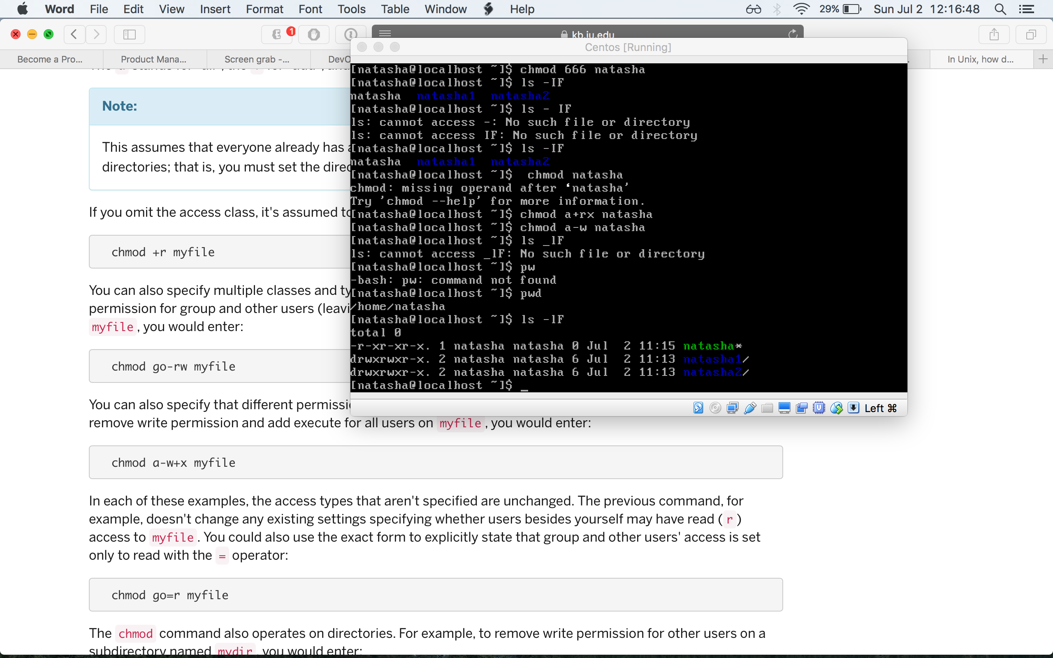

Write two lines in a file and display it to the screen

